Specialized Dictionary

What is Specialized Dictionary
# Source: AI Source: Provided by: [Data Path: Persons Table -> ID Column: 1, Name_En Column: Motasem Essam] -> From: [Chatgpt (GPT-4-turbo)] on [7/30/2025]
A Specialized Dictionary (also called a technical or subject-specific dictionary) is a reference work that focuses on the terminology and vocabulary of a specific field or profession. It provides precise definitions of words as they are used within that domain, often including abbreviations, symbols, and discipline-specific meanings.

✅ Key Features:
# Source: AI Source: Provided by: [Data Path: Persons Table -> ID Column: 1, Name_En Column: Motasem Essam] -> From: [Chatgpt (GPT-4-turbo)] on [7/30/2025]
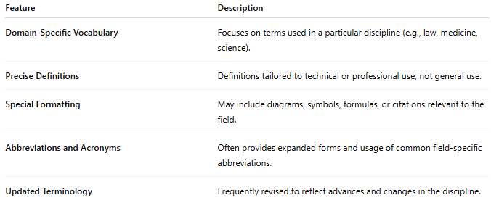
Feature | Description
Domain-Specific Vocabulary | Focuses on terms used in a particular discipline (e.g., law, medicine, science).
Precise Definitions | Definitions tailored to technical or professional use, not general use.
Special Formatting | May include diagrams, symbols, formulas, or citations relevant to the field.
Abbreviations and Acronyms | Often provides expanded forms and usage of common field-specific abbreviations.
Updated Terminology | Frequently revised to reflect advances and changes in the discipline.

👤 Primary Users:
# Source: AI Source: Provided by: [Data Path: Persons Table -> ID Column: 1, Name_En Column: Motasem Essam] -> From: [Chatgpt (GPT-4-turbo)] on [7/30/2025]
- Professionals and practitioners
- Researchers and academics
- Students in technical or professional fields
- Translators and technical writers

📘 Examples of Specialized Dictionaries:
# Source: AI Source: Provided by: [Data Path: Persons Table -> ID Column: 1, Name_En Column: Motasem Essam] -> From: [Chatgpt (GPT-4-turbo)] on [7/30/2025]
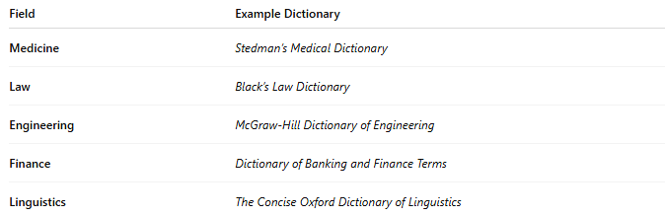
Field | Example Dictionary
Medicine | Stedman’s Medical Dictionary
Law | Black’s Law Dictionary
Engineering | McGraw-Hill Dictionary of Engineering
Finance | Dictionary of Banking and Finance Terms
Linguistics | The Concise Oxford Dictionary of Linguistics

🟢 Benefits:
# Source: AI Source: Provided by: [Data Path: Persons Table -> ID Column: 1, Name_En Column: Motasem Essam] -> From: [Chatgpt (GPT-4-turbo)] on [7/30/2025]
- Ensures clarity and accuracy in professional communication
- Supports learning and research in technical domains
- Helps avoid misunderstandings in specialized contexts

🔴 Limitations:
# Source: AI Source: Provided by: [Data Path: Persons Table -> ID Column: 1, Name_En Column: Motasem Essam] -> From: [Chatgpt (GPT-4-turbo)] on [7/30/2025]
- Not suitable for general vocabulary needs
- May be too technical for non-specialist readers
- Can become outdated if not regularly revised

